ALPHA MILESTONE DOCUMENT

### PROCESS

We spoke on the first day about changes we would like to see in the game and created tasks for them then on Wednesday the 20th we hosted some playtests where 7 people came and tried the game and we wrote down their feedback and created tasks to address their issues.

We prioritised and ordered these tasks and organised our milestones and goals for the Alpha build. We purposefully tried to keep our planned tasks to a minimum as to not overscope and to reduce time spent bug fixing and optimising in the future sprints.

## PLANNED PROGRAMMING TASKS

* Create tech tree system (est. 1-2 weeks)
  + Button system based off time
* Create resource storage building (est. 1 week)
* Create worker XP system (est. 1 week)
  + Increase the amount of resources they gather
* Add fishing (est. 1-2 days)
  + Just the same as mining and woodcutting but with different animations
* Add fog of war system (est. 1-2 weeks)
  + Disappears when player units are in range
    - Encourages exploration
* Make the buildings have to be built by workers rather than instant (est. 1 week)
  + Make building not be able to be built in corruption
* Add house system to increase maximum unit count (est. 1 week)
* Fix bugs and work on backlog (est. 4 weeks)

## PROGRAMMING BACKLOG (in order of importance)

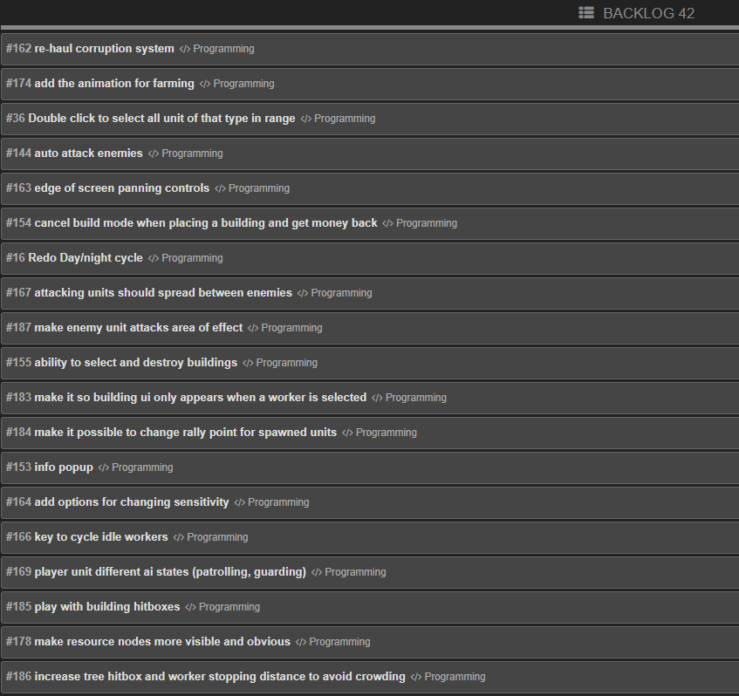

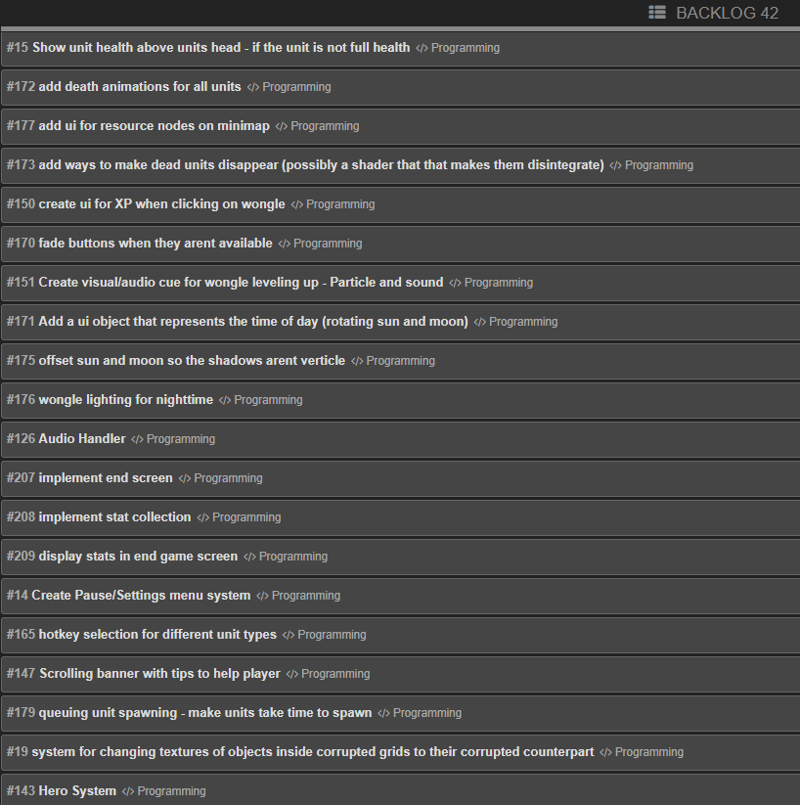

## PLANNED ART TASKS

Week1

* Drew environment concept arts including the plan and assets
* Create fishing resources including animations, a rod, and assets to pull from the water
* Develop assets for storage, housing (with variations), research building, barracks, and the Wonder
* Design and create a variety of new trees, plants and rocks that better conform to our psychedelic theme.

Week2

* Design and create a new land mass (floating island)
* Develop new Wongle Worker skins to give units more visual variation

Week3

* Design and create additional floating islands
* Develop various new animations including building and death animations for Wongle Workers
* Upgrade previous building textures to be cohesive with the games art style
* Alter styles of existing buildings for art cohesion
* Layout the environment and add ambient lighting

Week4

* Add house system to increase maximum unit count
* Potentially develop an armor system to better visually represent warrior unit experience
* Update UI based on play-testing feedback to increase readability and reduce bleed across the game
* Add more environment assets that we need

Week5

* Address previous material shader issues
* Update UI to account for new systems
* Develop interface elements to determine how far through the day/night cycle the game is
* Fix various material/normal issues across the game
* Review various actions and determine the need for new particle effects/icons to make interactivity more clear to the user
* Review lighting across the game to make sure key assets are always visible to the player

## ART BACKLOG

